Term End Milestone-2 (Project -1)

**Predicting the Mortality based on Clinical Data of patients with Cardiovascular Disease**

DSC, Bellevue University

Supraja Rapuru

DSC680-T301 Applied Data Science (2225-1)

 Professor Catie Williams

07/03/2022

**Topic: Predicting the Mortality based on Clinical Data of patients with Cardiovascular**

Heart failure occurs when the heart is not able to pump enough blood to the body. HF are only a subgroup of all the cardiovascular diseases that comprehend also coronary heart diseases (heart attacks), cerebrovascular diseases (strokes) and other pathologies that altogether kill every year approximately 17 million people around the world.

Machine learning applied to medical records can be useful to predict the survival of a patient, highlighting patterns and even ranking the features to understand which are risk factors, possibly undetectable by doctors.

**Business Problem :**

Cardiovascular Disease often used interchangeably with “heart disease”, generally refers to conditions that involve narrowed or blocked blood vessels that can lead to a heart attack, chest pain (angina) or stroke. Other heart conditions, such as those that affect your heart's muscle, valves, or rhythm, also are considered forms of heart disease.

The purpose of this project is to predict the effects of different parameters recorded in the data to predict mortality of the patient. By predicting so the physicians can determine high risk patients and can take better care of them thus helping them survive.

**Background :**

### Cardiovascular diseases (CVDs) are the number 1 cause of death globally, taking an estimated 17.9 million lives each year, which accounts for 31% of all deaths worlwide.

### Heart failure is a common event caused by CVDs and this dataset contains 12 features that can be used to predict mortality by heart failure.

### People with cardiovascular disease or who are at high cardiovascular risk (due to the presence of one or more risk factors such as hypertension, diabetes, hyperglycaemia or already established disease) need early detection and management wherein a machine learning model can be of great help.

**Data Explanation:**

This project uses the UCI Machine Learning Repository's heart failure clinical records dataset

Heart failure clinical records Data Set contains the medical records of 299 patients who had heart failure. The dataset contains 11 clinical features (some of them are binary, others are numerical), the follow-up period and the label DEATH_EVENT that indicates whether or not the patient has died.

We can find some features strictly related to medical aspects like levels of enzymes, sodium, creatinine and platelets in the blood and others that are more common like age, sex or smoking.

We have 13 parameters in the dataset

We will be analyzing the effect of below parameters

* Age of Patient
* CPK Levels
* Ejection Fraction
* Platelets
* Serum Creatinine
* Serum Sodium

The table below lists out the details of all attributes in the dataset being used for the analysis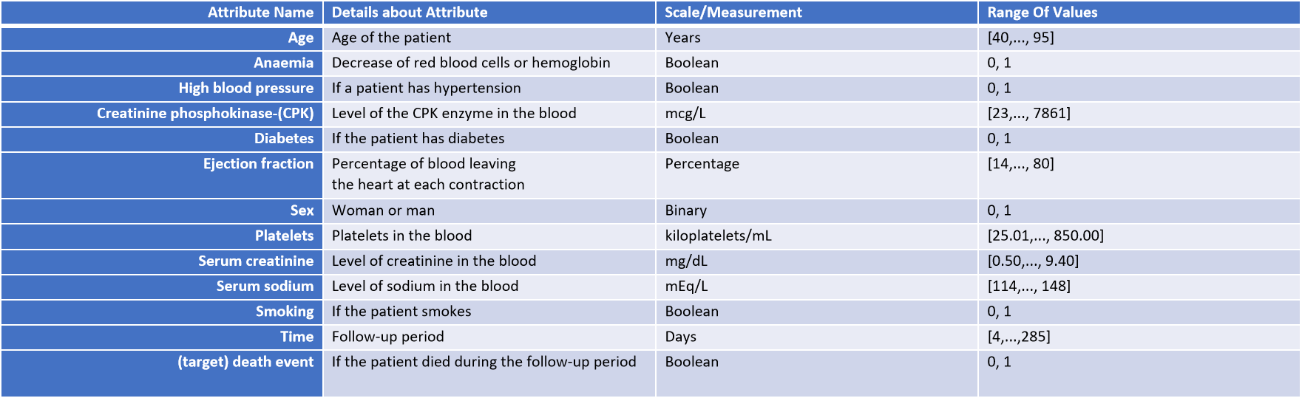

**Methods:**

For this project, below series of classification models used to perform classification of the mortality.

* Decision tree
* Random forest
* Linear regression
* Logistic regression
* Support vector machine (linear, poly, rbf)
* K nearest neighbors
* Naive bayes

**Analysis :**

Histogram Plots for the variables in question

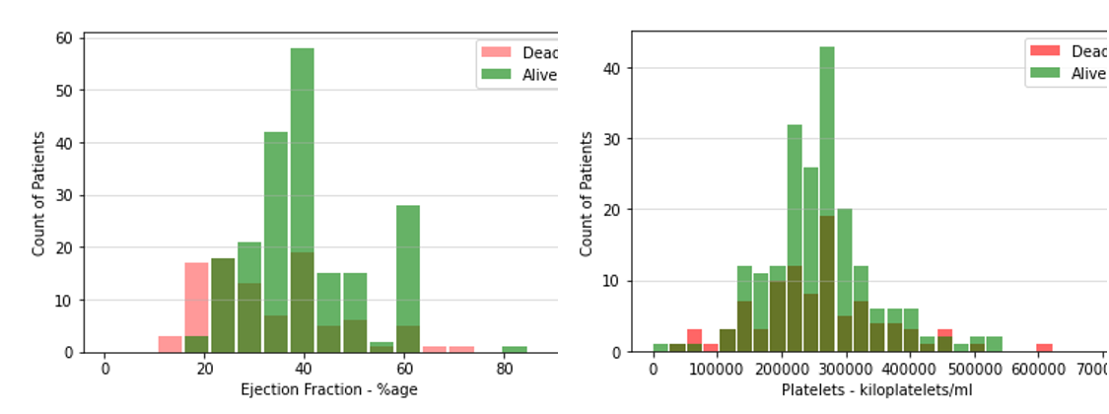

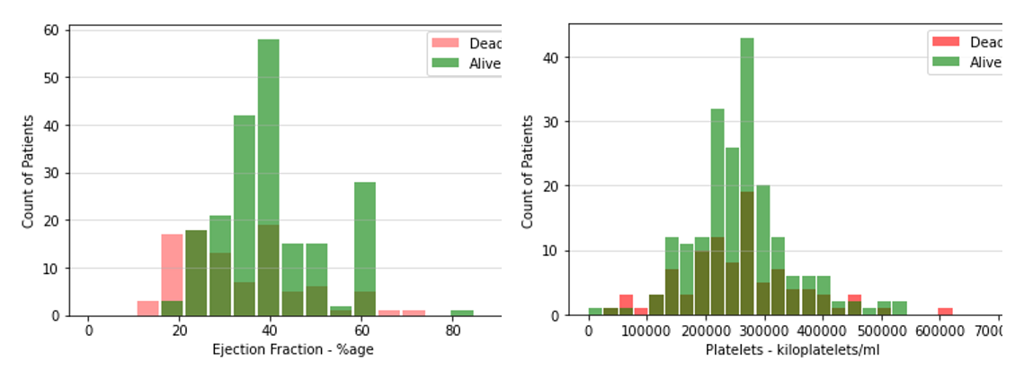

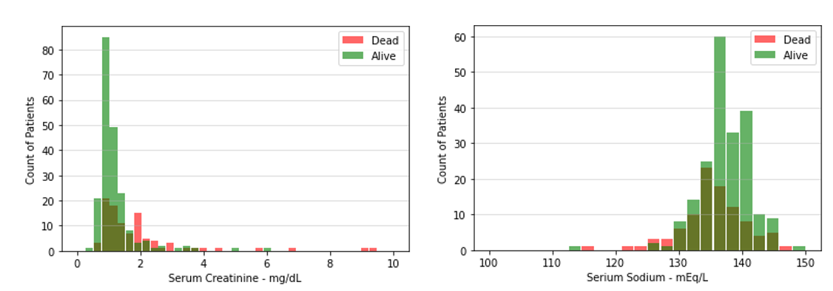

From the histograms, we may be able to see something but its not clearly visible

1. Age effects the mortality. As age increases the risk becomes higher
2. With lower Ejection fraction the risk increases
3. With higher serum creatinine levels risk increases
4. With lower serum sodium levels risk increases

**Decision tree**

Decision trees are one of the most widely known machine learning models. They are non-parametric models that learn by recursively split the predictor space (and so the train samples) according to the best feature (greedy approach) until the tree reaches a constrained depth, the subsets contain elements of only one class or it meets another stopping criterion (e.g. less than 5 samples in the subset).

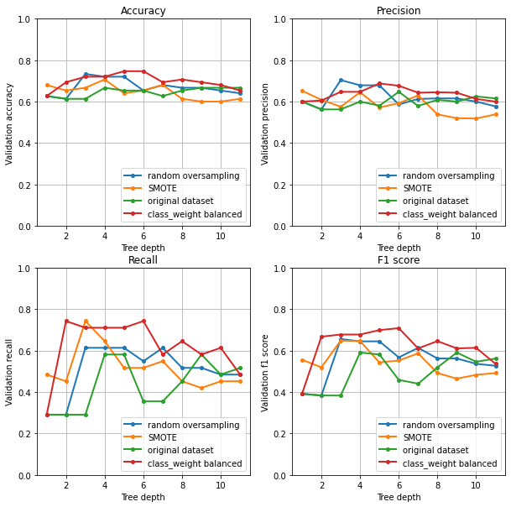

The best model seems to be the decision tree on the original dataset with class_weight = balanced with a depth of 6.

**Random forest**

Random forest is an ensemble model based on a number of decision trees. The decision trees are trained with data, sampled with repetition from the original dataset (bagging).

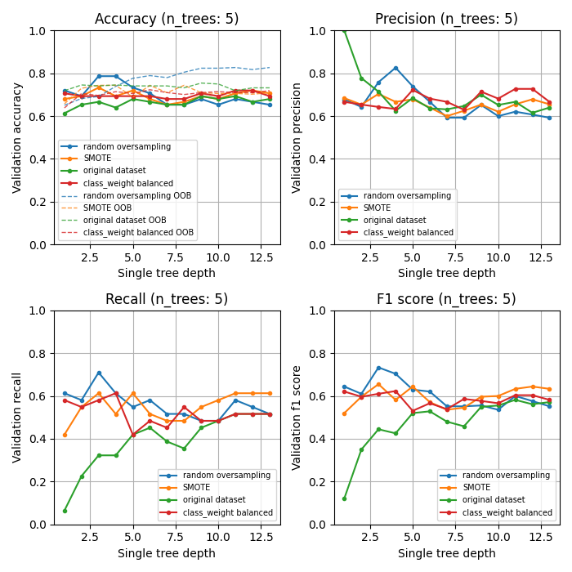

**Linear Regression**

Linear regression is one of the simplest models in machine learning. It is a generalized linear model capable of fitting a linear equation to observed data. Usually, linear regression is not suggested for binary classification because it can output values below 0 or above 1 (nonsense, assuming probabilistic meaning). In this case I decided to perform it anyway to compare the results with another regression technique called logistic regression that instead is very suitable for binary classification.

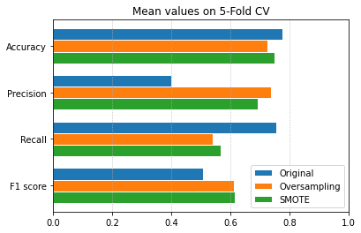

**Logistic Regression**

Logistic regression is a generalized linear model in which the link function is not the identity (as in the case of linear regression) but is the logit. In this way every prediction is bounded between 0 and 1, assuming a probabilistic meaning. For this reason, logistic regression is very suitable for binary classification.

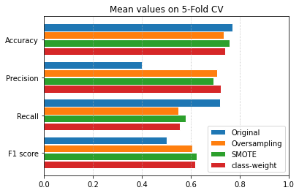

**Support Vector Machine**

Support vector machine is a powerful model used for both classification and regression. It consists in trying to fit an hyperplane that best divides the dataset into the two classes by maximizing the margin (the distance between the hyperplane and the closest points).

To better see how soft margin svm works with different kernels, we can see the classification according to serum_creatinine and ejection_fraction. Then the same algorithm will be tested on all the 7 features of the original, oversampled and SMOTE dataset.

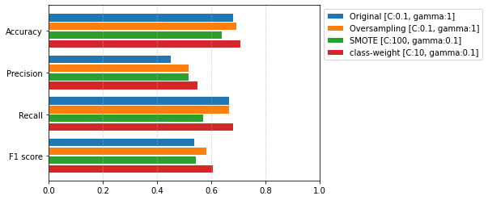

**K Nearest Neighbors**

KNN model tries to classify new points according to the class of the nearest neighbors. Nearest neighbors are evaluated according to a distance metric function and for each new point, only a fixed number of neighbors are taken into account. This model is quite simple but it doesn't scale well.

In fact, to predict a new point is necessary to store the entire dataset, so when the number of features or the number of records is very high, the computation could be heavy. Considering the way KNN learns, it is possible to re-train an already trained model on new data.

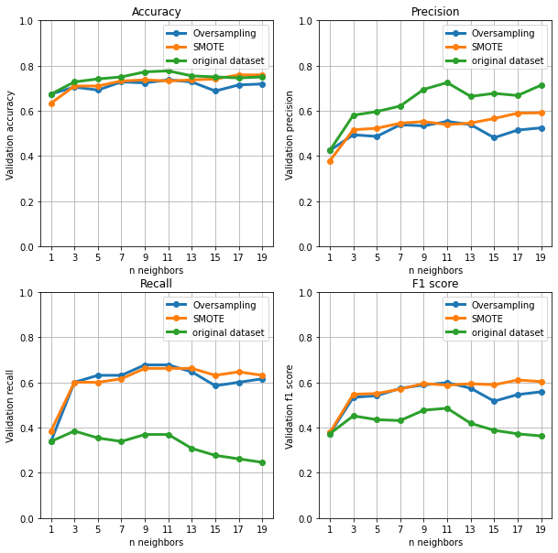

**Naive Bayes**

Naive bayes classifier is a probabilistic model based on the Bayes theorem in which is assumed a strong independence between the features. The concept is that every feature independently contribute to the final prediction.

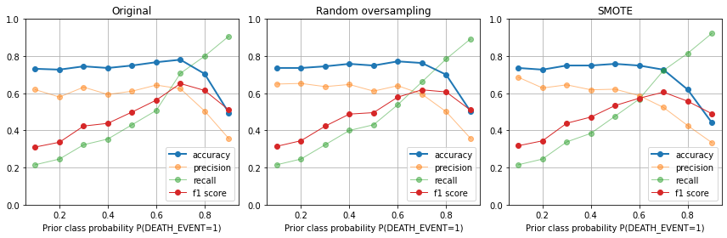

**Conclusion:**

Here we can see the results obtained with different models and different rebalancing techniques for the Hearth Disease dataset. Both accuracy and f1 score (inside parenthesis) are showed.

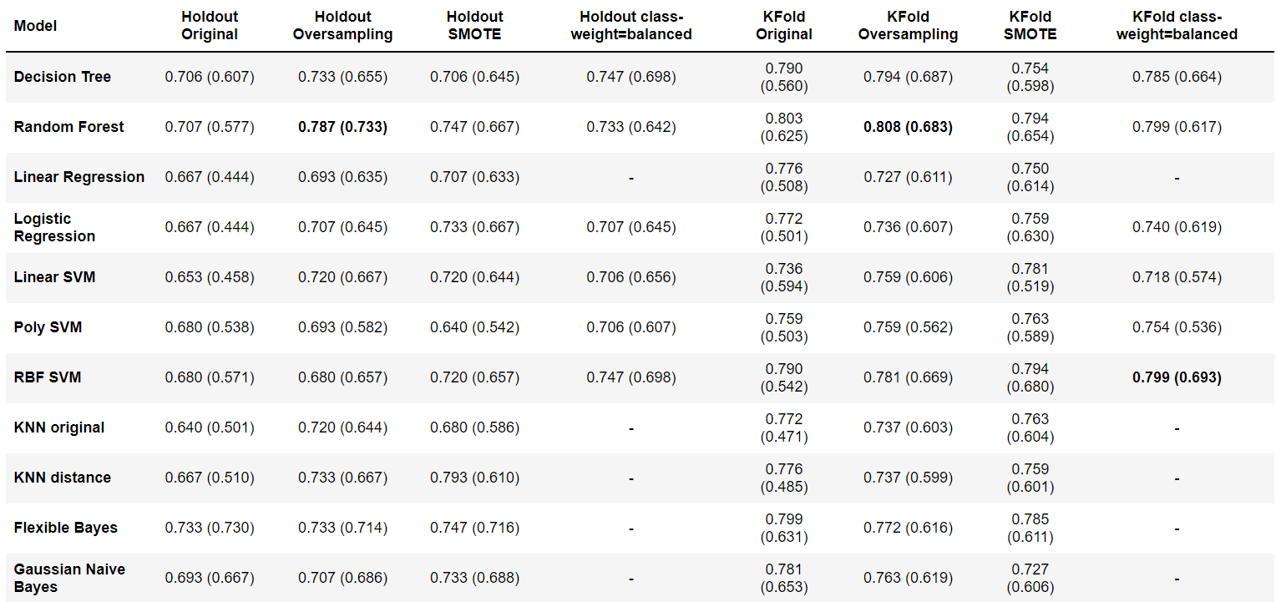

We can clearly see how using some rebalancing techniques the f1 score increase substantially. In some cases SMOTE performs better with respect to random oversampling, and the opposite in others. Furthermore, where is possible to apply it, also the use of the class-weight parameter increases the performances, sometimes outperforming the other techniques.

Then we noticed how using Gaussian Naive Bayes, even without respecting the hypothesis, leads to good results and also with a Bayes Classifier with KDE, the results are in line.

Best overall model seems to be the random forest trained on the over sampled dataset, that delivers the best results in terms of accuracy and f1 score.  
Also RBF-SVM with class-weights=balanced provides some good results on KFold.

For the models that allow it, it's possible to evaluate the ROC curve to select a threshold according to the main goal (minimize false positives or maximize true positives) but the results in the table are obtained by fixing the threshold at 0.5.

The overall results seem in line with the ones obtained in the reference paper [[1]](https://nbviewer.org/github/lorenzodenisi/Heart-Failure-Clinical-Records/blob/master/Heart Failures.ipynb" \l "references) but it's needed to keep in mind that the metrics are highly influenced by the small dimension of the dataset (75 samples in holdout validation set).

**Assumption**:

There were some concerns regarding the sample size of the data. Since the data was from a single location, there might be some other factors in play which can be due to habits of people to that specific region or part of the world and may not be reflecting in the data. If we get more geographically separated data, we might come up with better model. This model may be more effective in the region where data comes from but our assumption that it will work for all might be wrong.

**Limitations:**

While analyzing separately, I did notice time (in days) between follow up visits was making the risk lower. It is anyways evident that if you go on regular follow ups, you will be able to know the problem before its too late and you may have the opportunity to act to decrease the risk.

**Challenges:**

The biggest challenge in dealing with the small dataset, imbalanced and unavailability of time duration between visits. Dealing with this information while still finding meaningful patterns was a challenge.

**Future Uses:**

This information can be used as supporting material by medical professionals and suggest preventive course of action in time for patients. Also can be extended into smart wearable devices so that patients can be alerted/reminded the actions to be taken.

**Recommendations:**

To ensure risk factors are properly identified in the collected values, I recommend obtaining clinical

information about the patients at periodic intervals and calibrate model

**Implementation Plan:**

As we already discussed in the methodology section about some of the implementation details.

So, the language used in this project is Python programming. We’re running python code in anaconda navigator’s Jupyter notebook. Jupyter notebook is much faster than Python IDE tools like PyCharm or Visual studio for implementing ML algorithms. The advantage of Jupyter notebook is that while writing code, it’s really helpful for Data visualization and plotting some graphs like histogram and heatmap of correlated matrices.

**Ethical Considerations:**

* This Data contains processed physical images information related to multiple verities of rice and does not contains any PII-related information.
* Datasets and information on data were extracted from the public websites 🡪 UCL machine learning repositories.
* This data research is not going to harm any privacy.

**References :**

[1] D. Chicco, G. Jurman. "Machine learning can predict survival of patients with heart failure from serum creatinine and ejection fraction alone", 2020

[2] N. V. Chawla, K. W. Bowyer, L. O. Hall, W. P. Kegelmeyer. SMOTE: Synthetic Minority Over-sampling Technique, 2002

[3] G. H. John, P. Langley. Estimating Continuous Distributions in Bayesian Classifiers, 1995

**Appendix :**

The notebook can be found @ **<https://github.com/suprajarapuru/Applied-Data-Science/blob/main/Project%201/Heart%20Failures.ipynb>**

**Dataset Screenshot:**

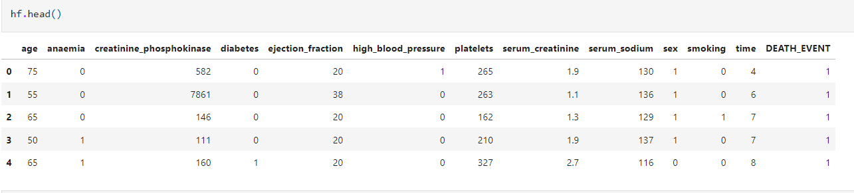

**Correlation Matrix:**

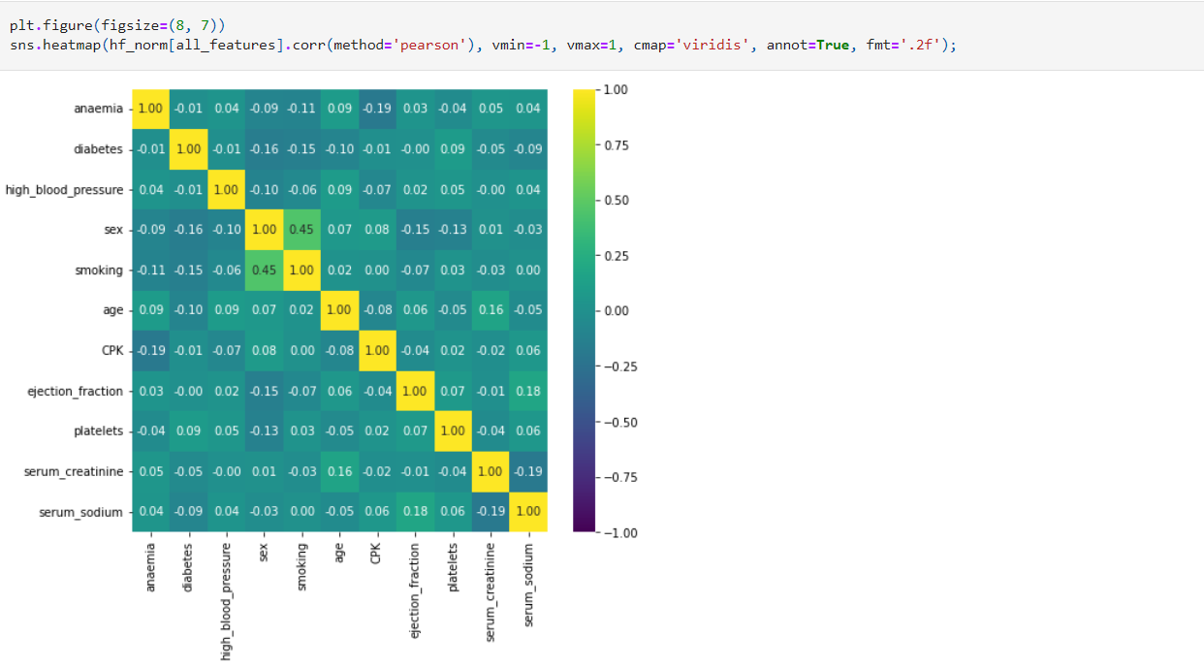

**Feature selection** Mutual information:

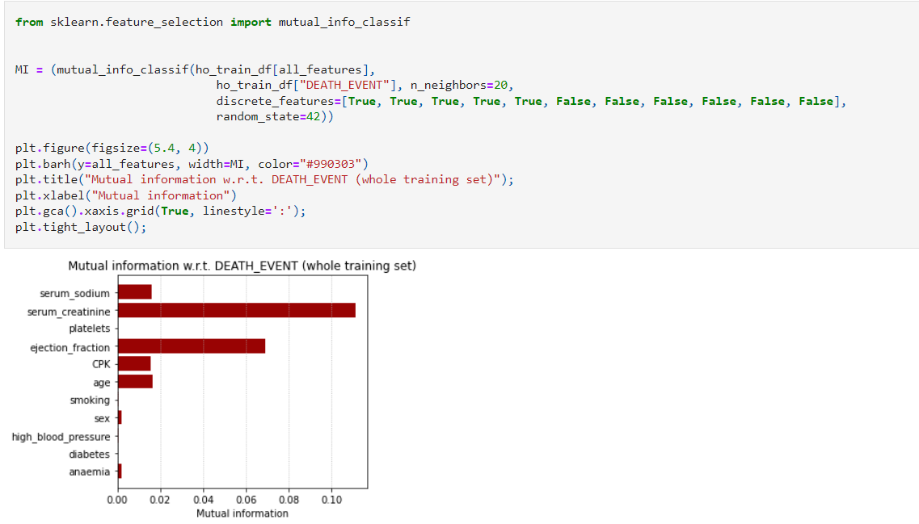

**Class Imbalance:**

